Goal
By the end of this stage, your machine should look like this:
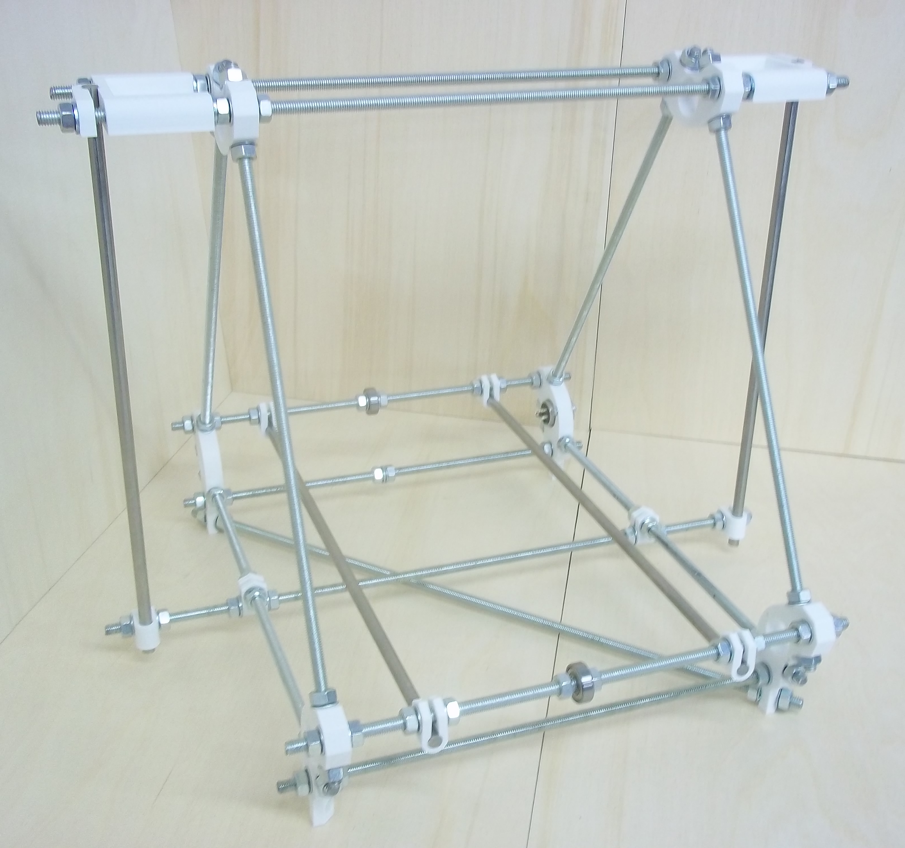

Tools
You will need the following tools
- M8 (13mm) spanner
- Adjustable spanner
- 300mm Rule
- Lasercut MDF Measuring template (supplied with kit)

Step 1: Frame triangles
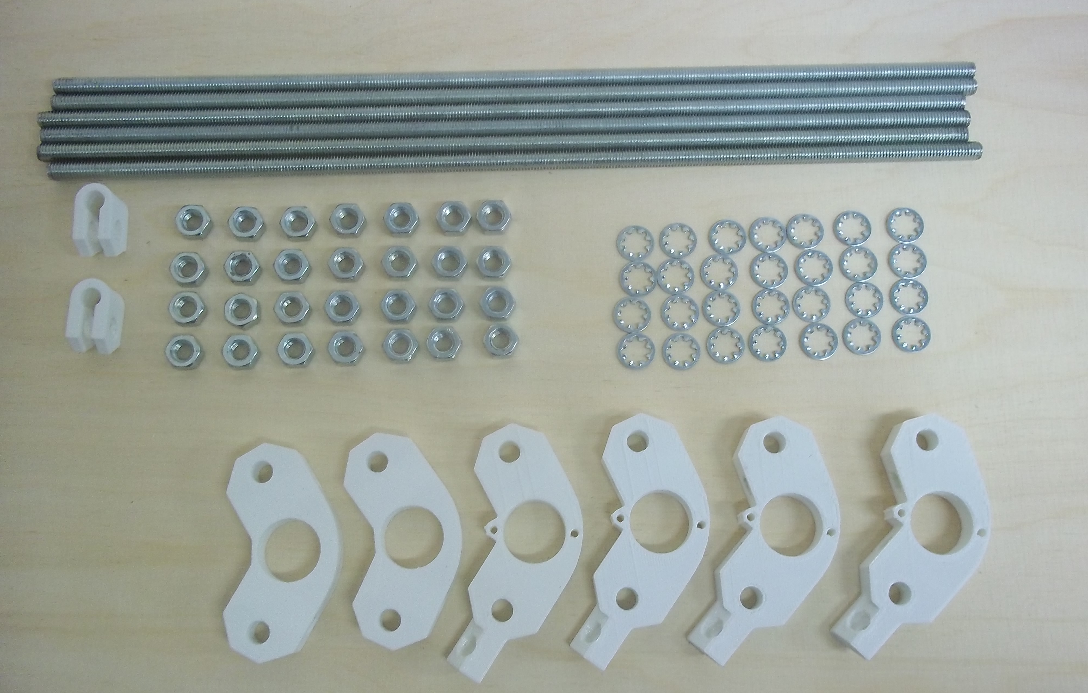
Item | Quantity
370mm M8 rods | 6
Printed frame vertex with foot | 4
Printed frame vertex | 2
Printed U clips | 2
M8 nuts | 28
M8 lock washers | 28
Note that there are three types of printed U clips in your kit:

The ones on the left are the frame clips, the ones in the middle are the Z-drive flexible coupling clips, and the ones on the right are the printed-circuit-board clips. For this step you want the ones on the left.
Split the components into two equal sets, then loosely screw them together into each frame triangle. Make sure you slide a belt clamp along the bottom M8 threaded bars between the frame vertices with feet, with a serrated washer and nut either side. The other nuts should also all have serrated washers under them.
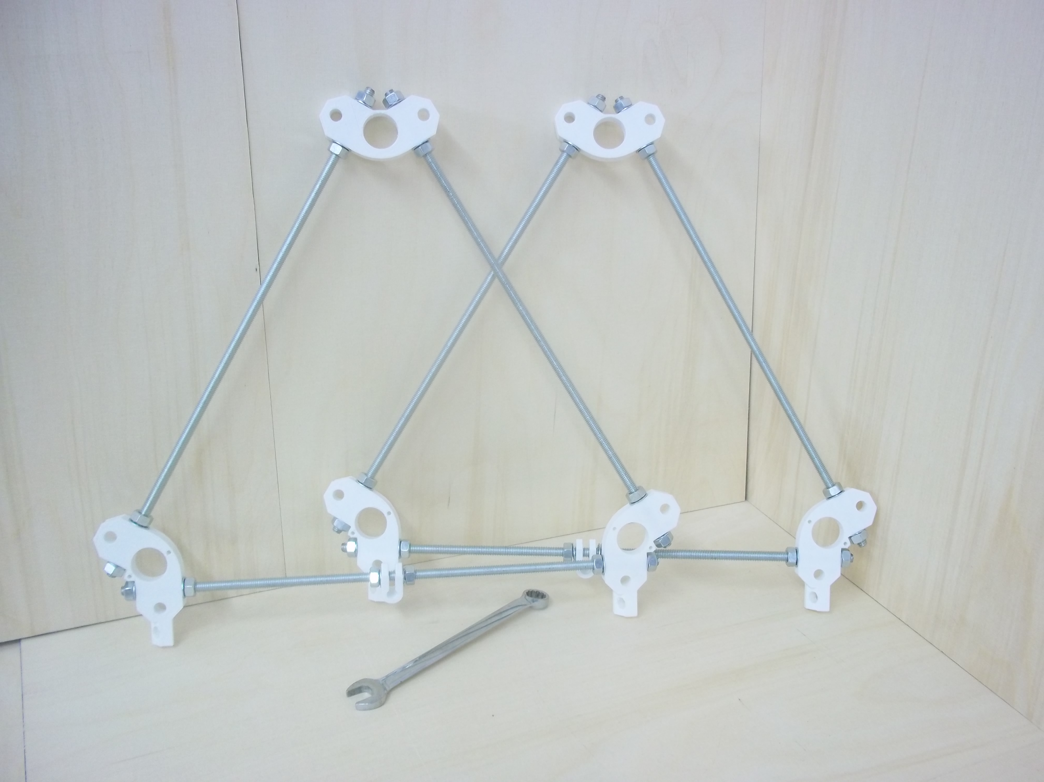
Make the gap between the frame vertices measured face to face next to where the nuts and washers tighten about 290 mm.

Your kit has a template to make it easy to get these measurements right.
Don't tighten anything at this stage.

Step 2: Cross bars
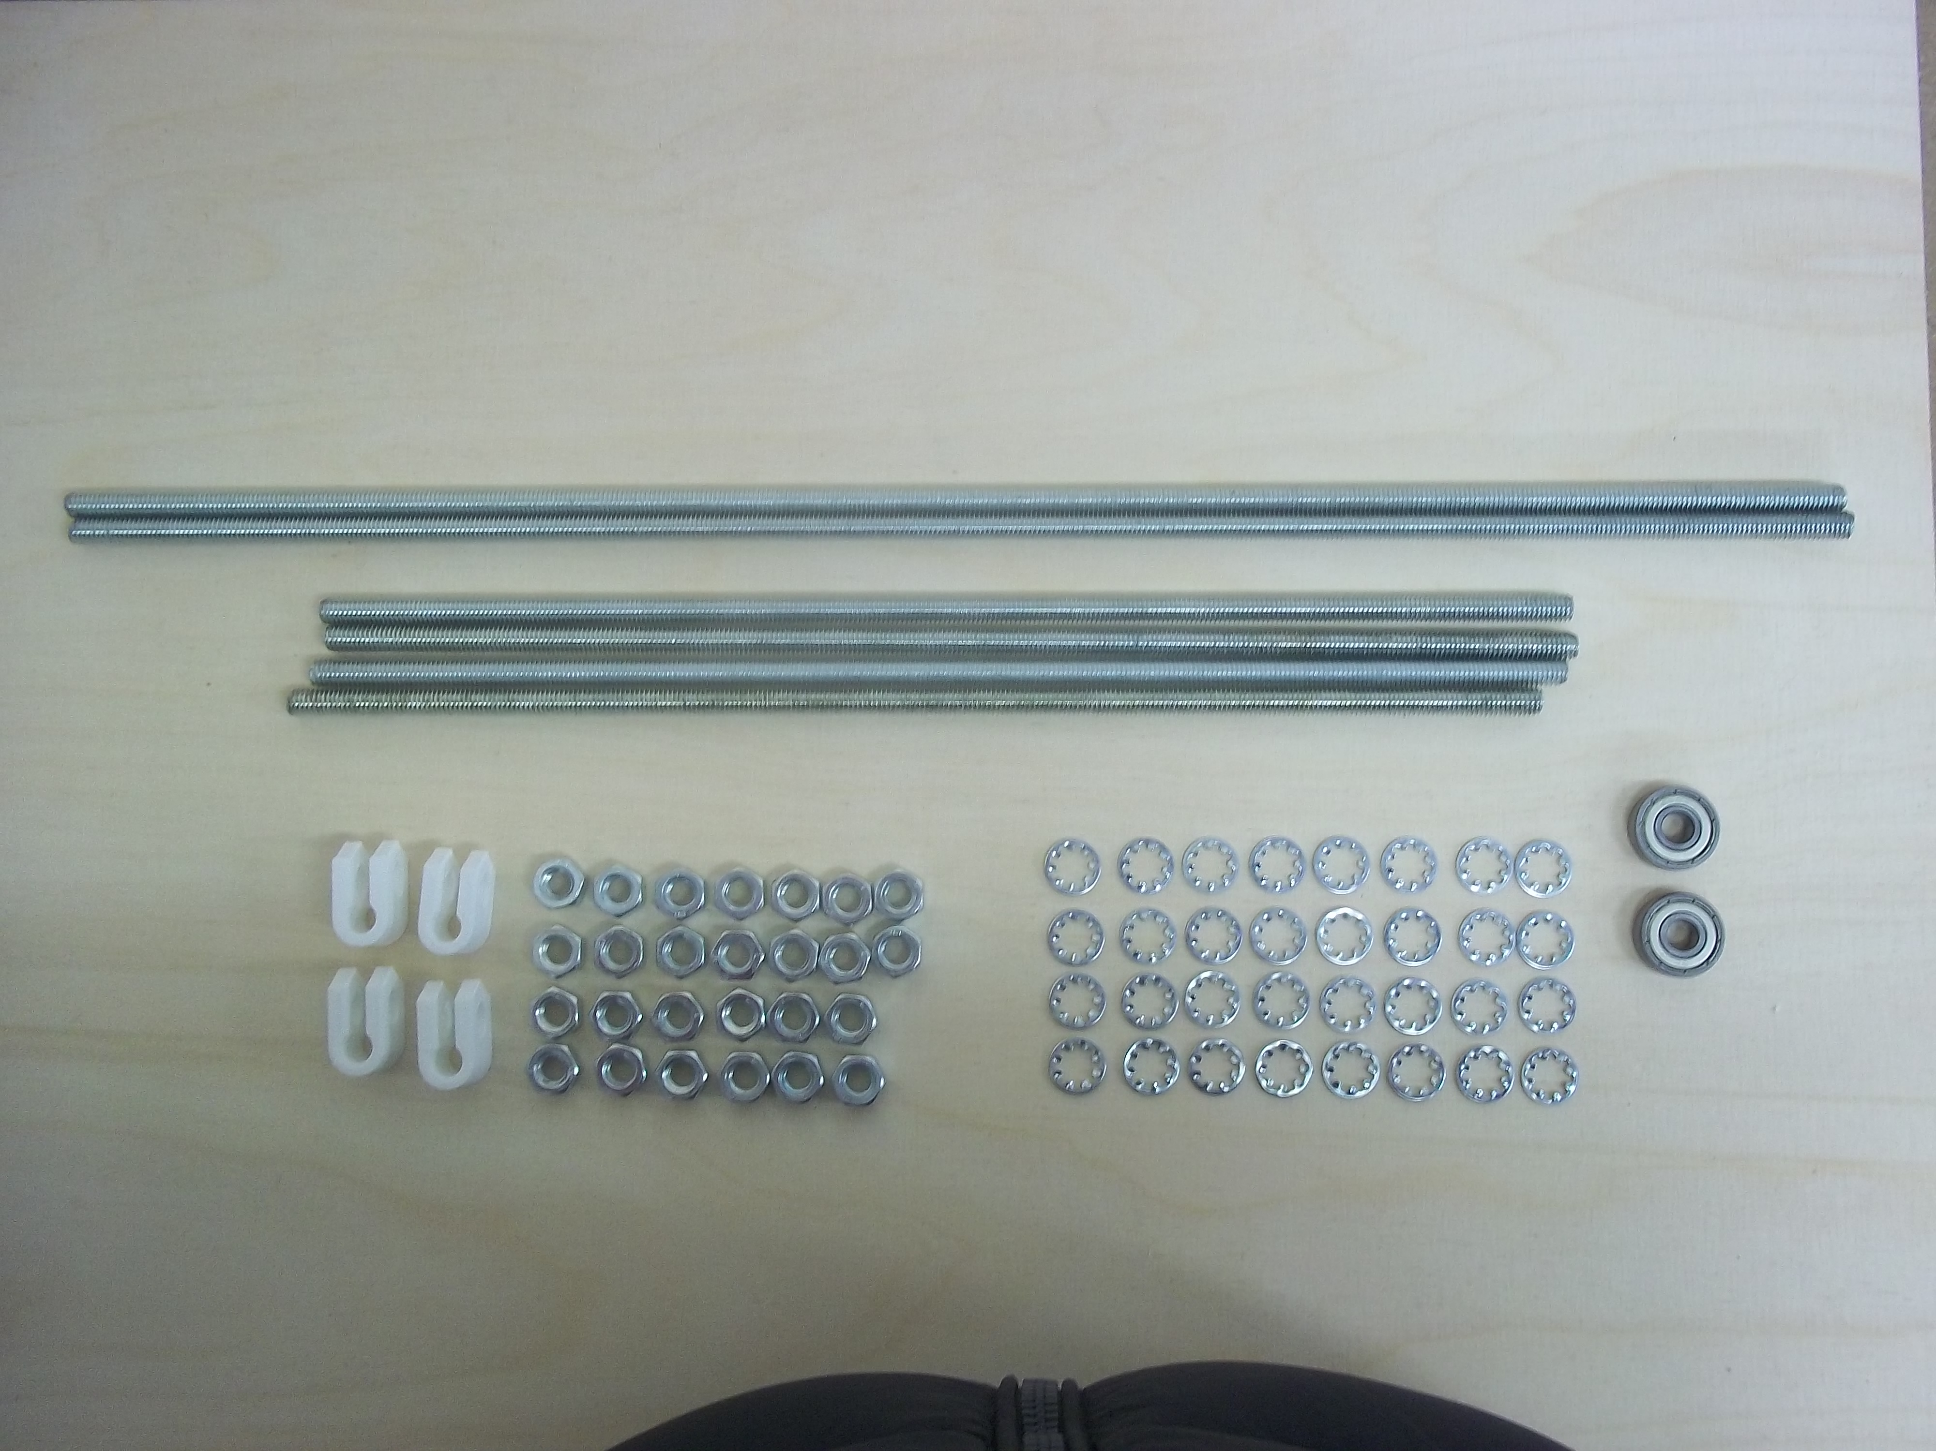
Item | Quantity
330mm M8 rods | 4
470mm M8 rods | 2
Printed U clamp | 4
8mm bearings | 2
M8 lock washers | 24
M8 nuts | 26

Assemble the bars as shown in this picture:
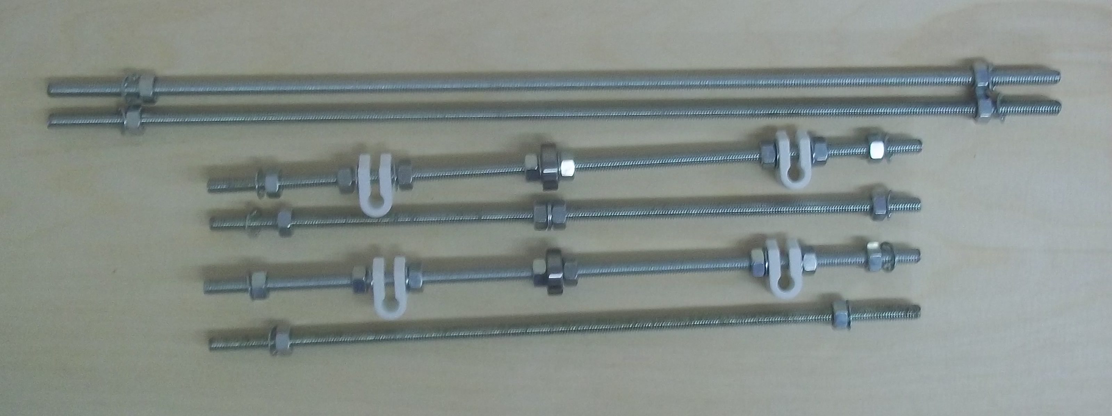
From top to bottom and left to right the sequences are:
- Lock washer, nut, lock washer, nut
- Lock washer, nut, lock washer, nut
- Lock washer, nut, nut, lock washer, U Clamp, lock washer, nut, nut, lock washer, bearing, lock washer, nut, nut lock washer, U clamp, lock washer, nut, nut, lock washer
- Lock washer, nut, nut, lock washer, lock washer,nut, nut, lock washer
- Lock washer, nut, nut, lock washer, U clamp, lock washer, nut, nut, bearing, nut, nut, lock washer, U clamp, lock washer, nut, nut, lock washer
- Lock washer, nut, nut, lock washer.

Step 3: Put them all together
Item | Quantity
M8 nuts | 12
M8 lock washers | 24
Firstly screw the cross bars into one of the triangles as shown, Next screw the second triangle to the other end of the cross bars; Use a locking washer and a nut on each rod end:
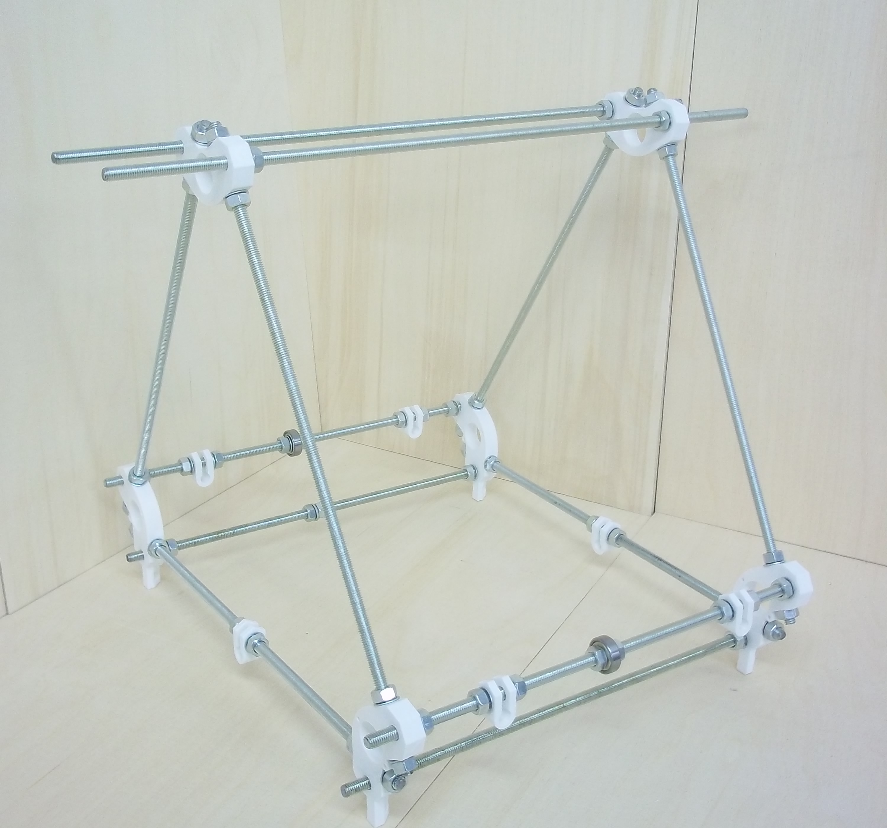

On the bottom, and using the numbers of the rods from Step 2:
And at the top attach the two long Rods: 1 and 2.
- Back top: Rod 3
- Back bottom: Rod 4.
- Front top: Rod 5.
- Front bottom: Rod 6.

Now go round the frame tightening everything up using two spanners. Tighten the triangles first, then the six bars in the x direction.

Needs measurement jig picture

Use the template to get the measurements right.
Make the gap between the faces of the vertices on the triangles 290mm, as mentioned above. Make the gap in the x direction between the faces of the vertices 273mm.
Get the two top rods even, with an equal amount projecting each side, then move the back one 5mm to the right and the front one 5mm to the left.
Try to get the measurements accurate. But it is more important to get the lengths equal than to get them precise.
You will find that you can make very fine adjustments when things are almost tight by slightly slackening a nut on one side of a join then tightening the nut on the other side.

Step 4: Z-motor mounts, diagonal, and power connector
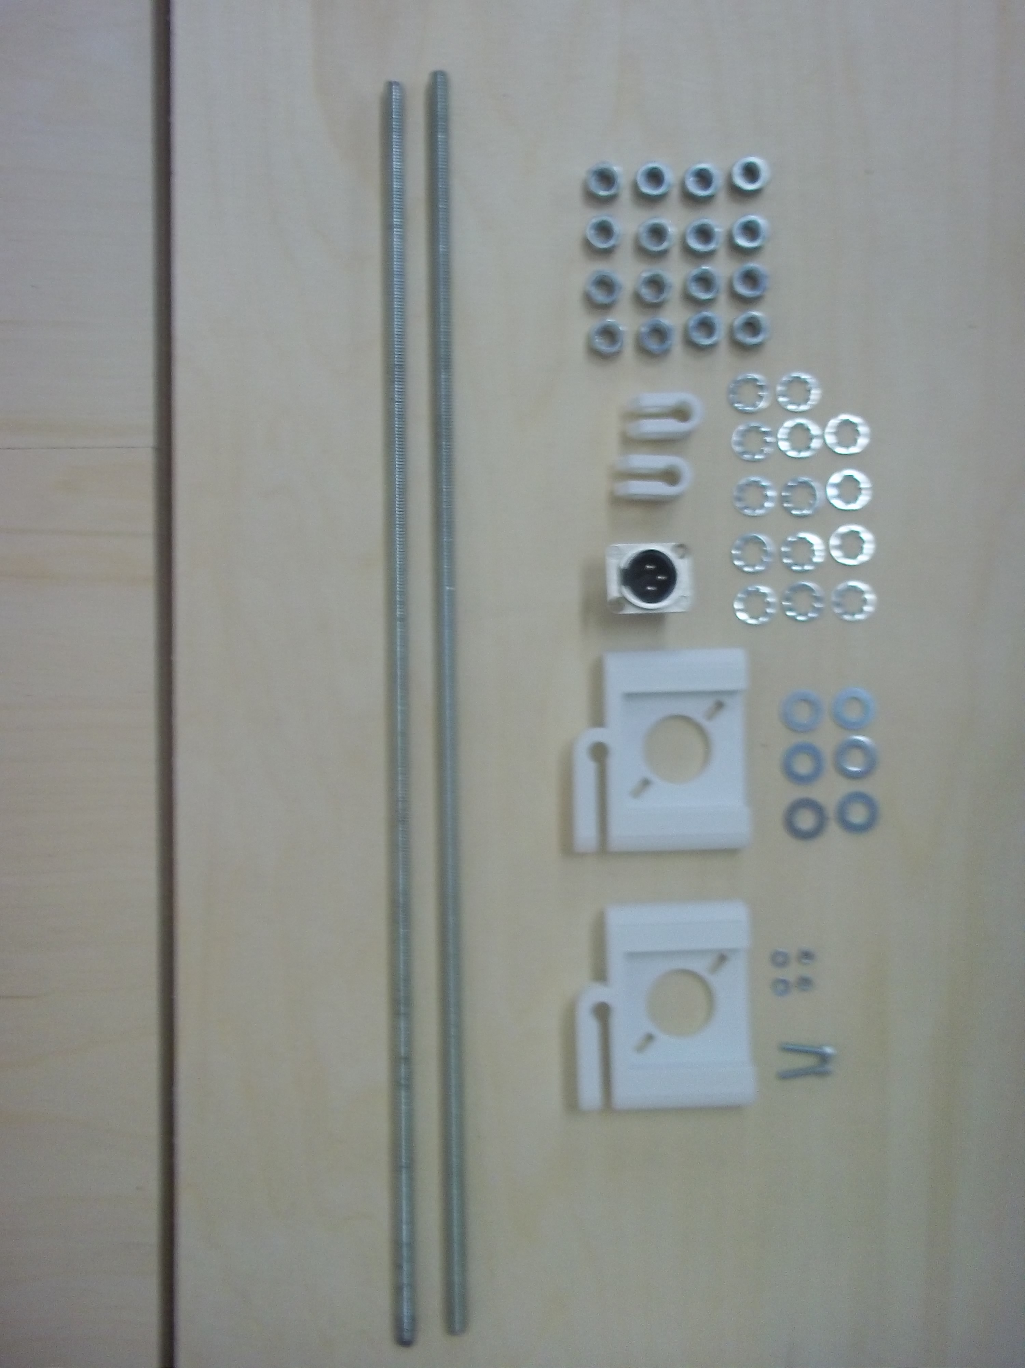
Item | Quantity
470mm M8 rods | 2
Printed Z motor holders | 2
Printed U clips | 2
M8 nuts | 16
M8 lock washers | 15
M8 washers | 6
20mm M3 caps | 2
M3 washers | 2
M3 nuts | 2
XLR socket | 1
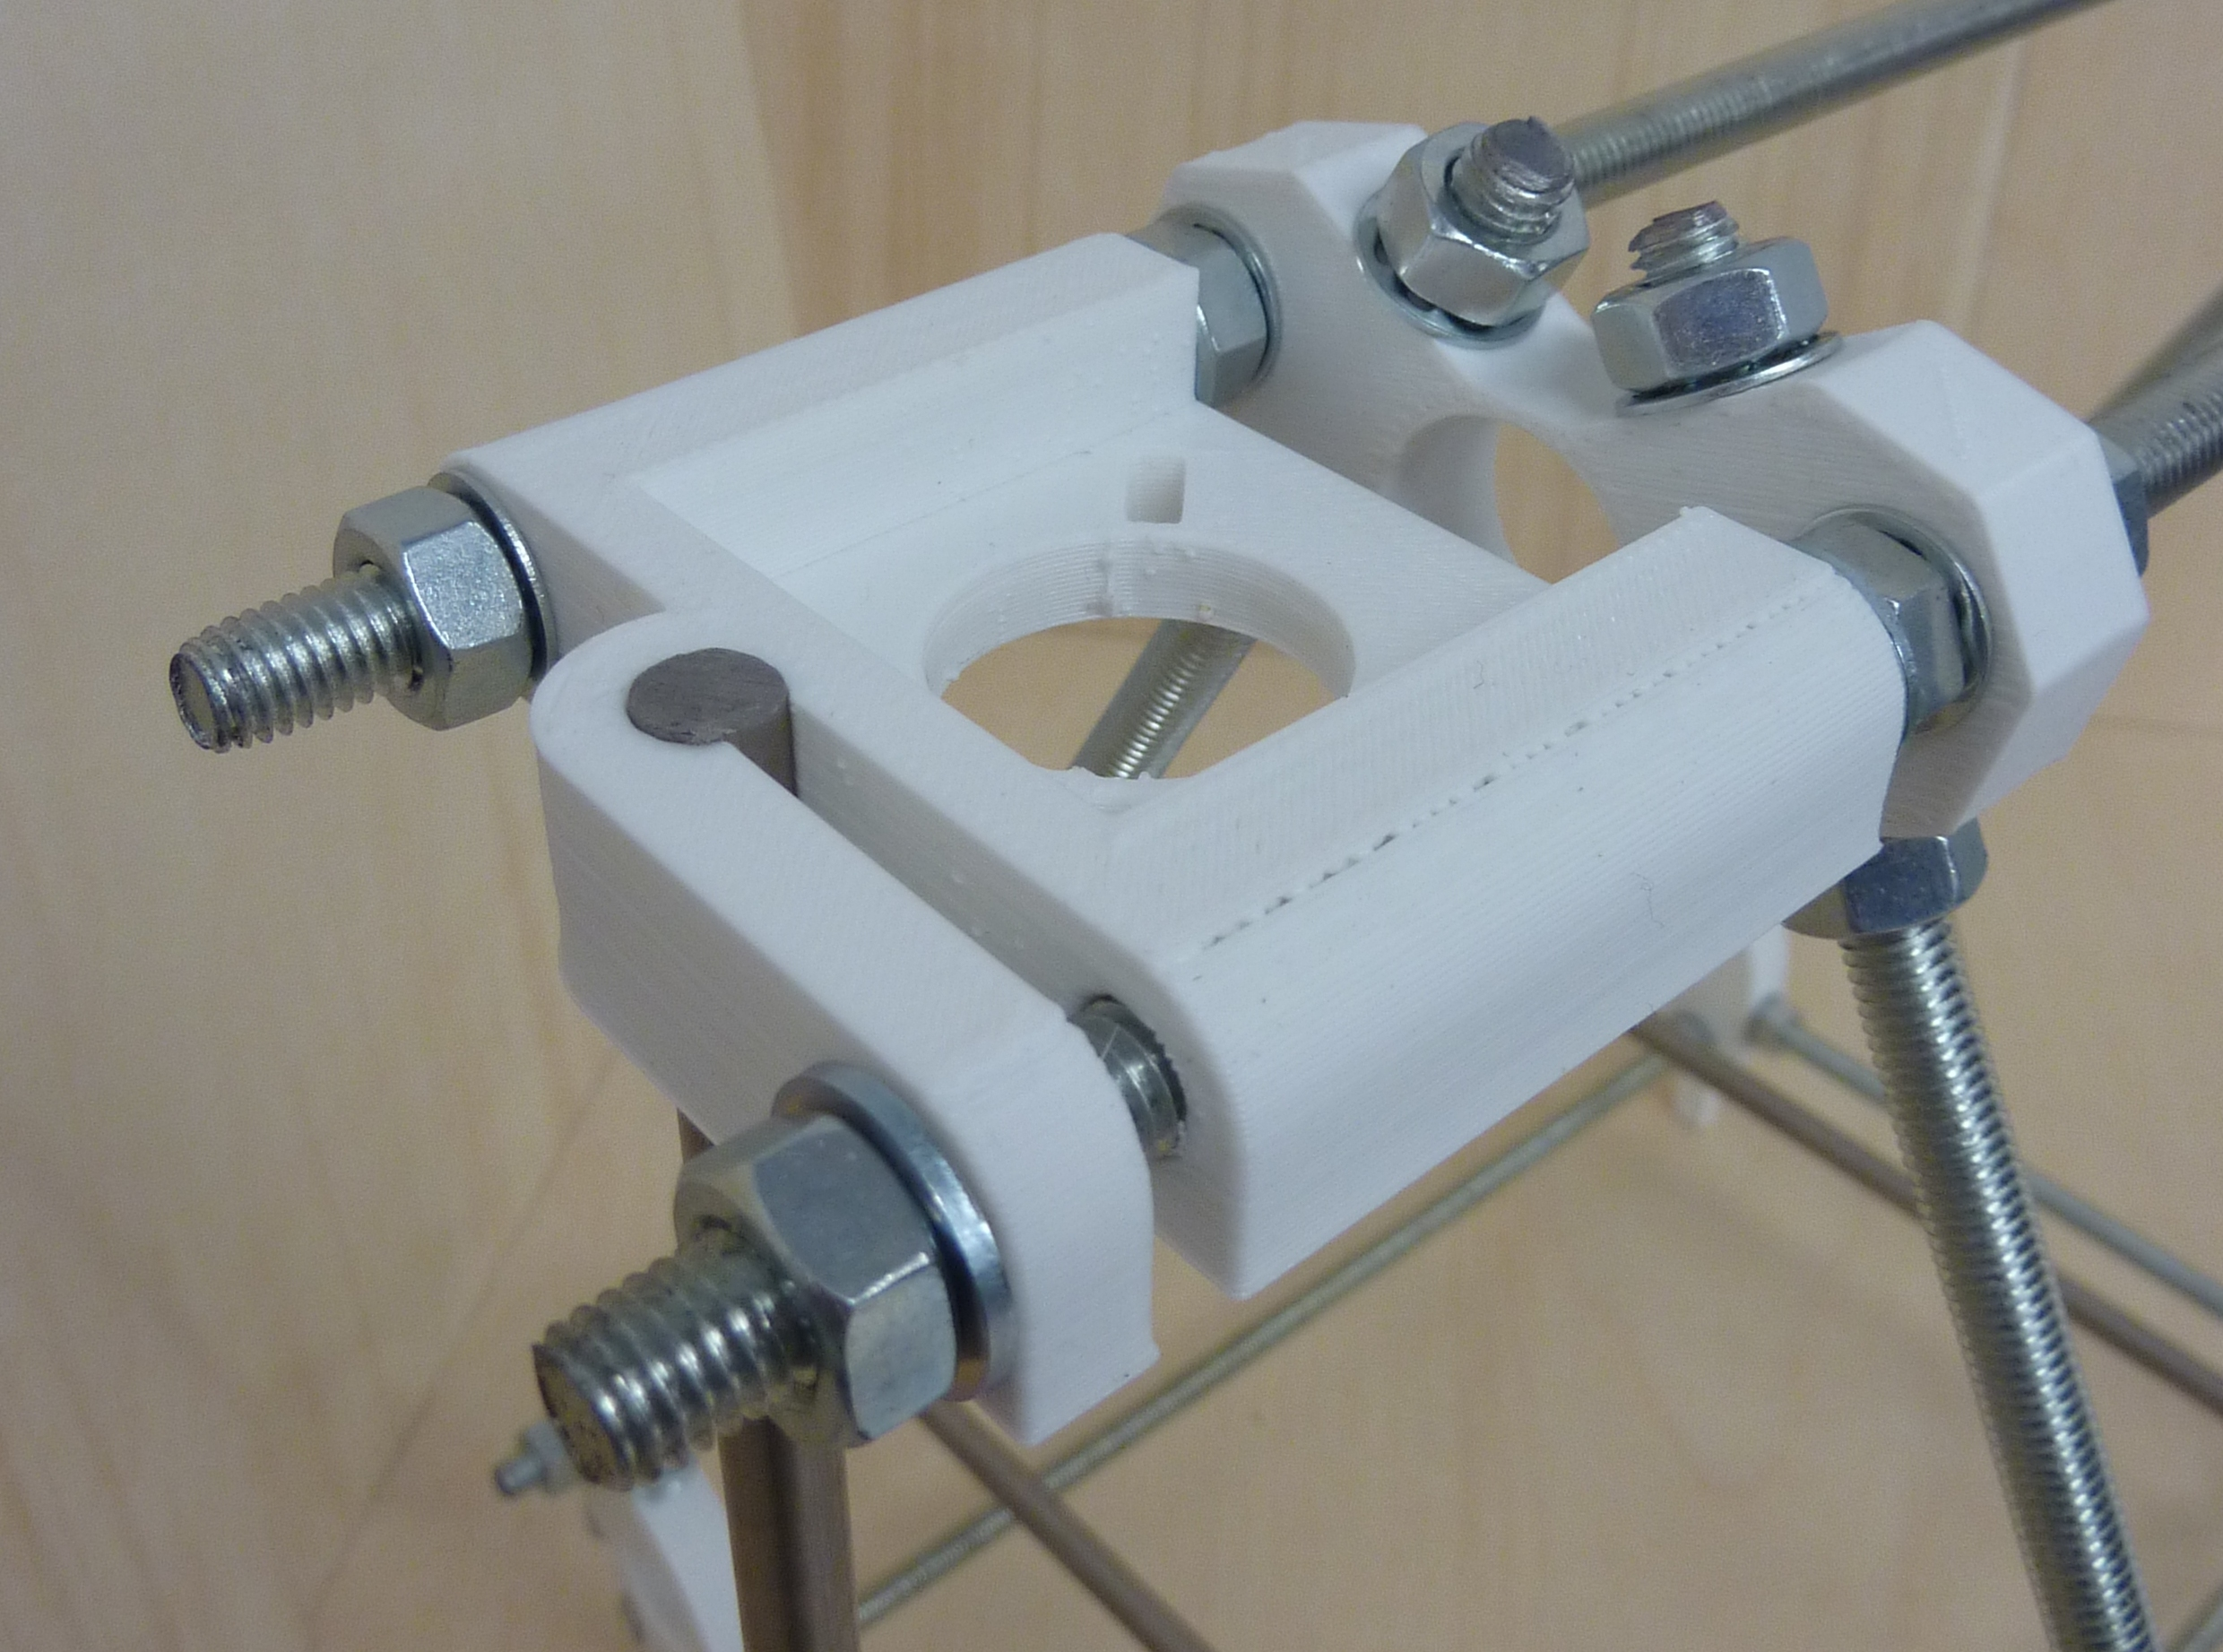

Put the two U clips already on the frame roughly in the middle of their bars, then push one of the 470mm rods through. You may have to twist it, using its thread to move it - it can be quite a snug fit. Use nuts and lock washers to put two more U clips on its ends for the Z smooth rods, as shown. Leave all these lose:

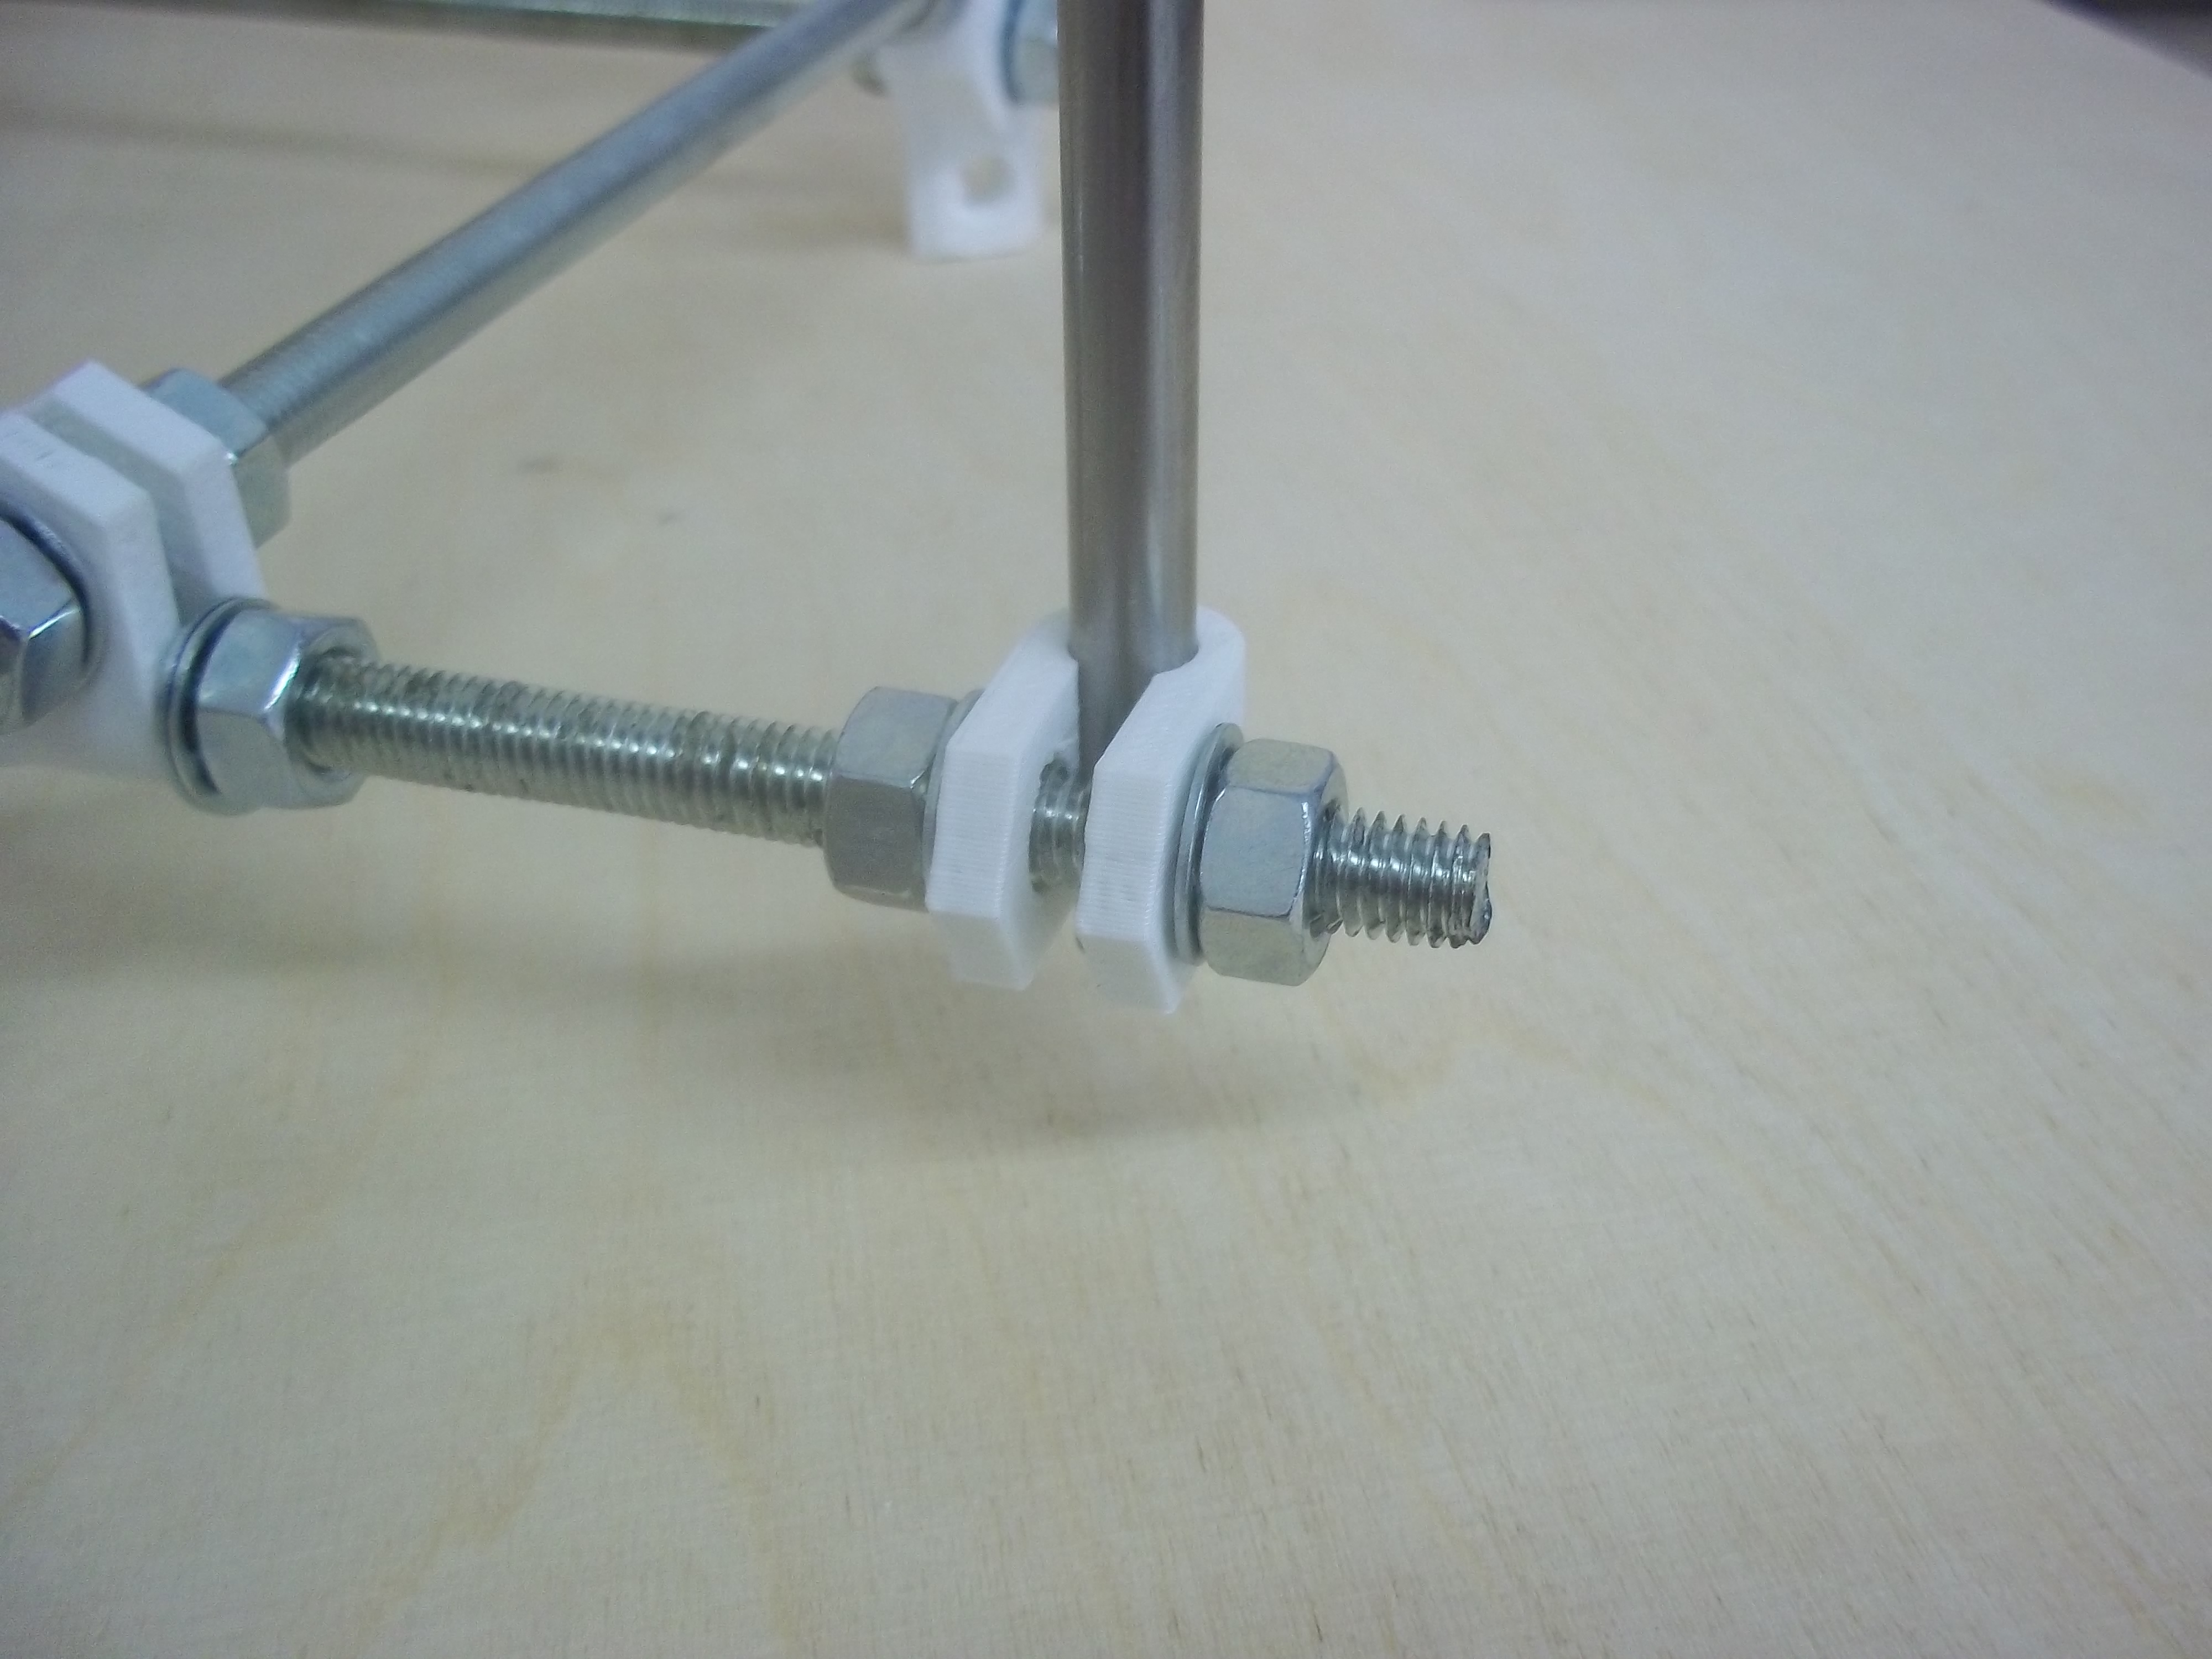

Next thread the base diagonal rod through two of the four feet. Put nuts and lock washers on it both inside and outside each foot, but leave them lose.
Put four smooth washers on the top bars, then put the Z motor mounts on as shown. Secure them with two nuts each, with one smooth washer and one lock washer. The smooth washer goes on the clamp that will hold the Z rods. Tighten the other nuts against their lock washers, but leave the Z-rod-clamp nuts lose:

Fit the XLR plug using the M3 screws, nuts and washers. The washers go under the nuts. Fit the plug so that the triangle formed by its three pins points upwards.

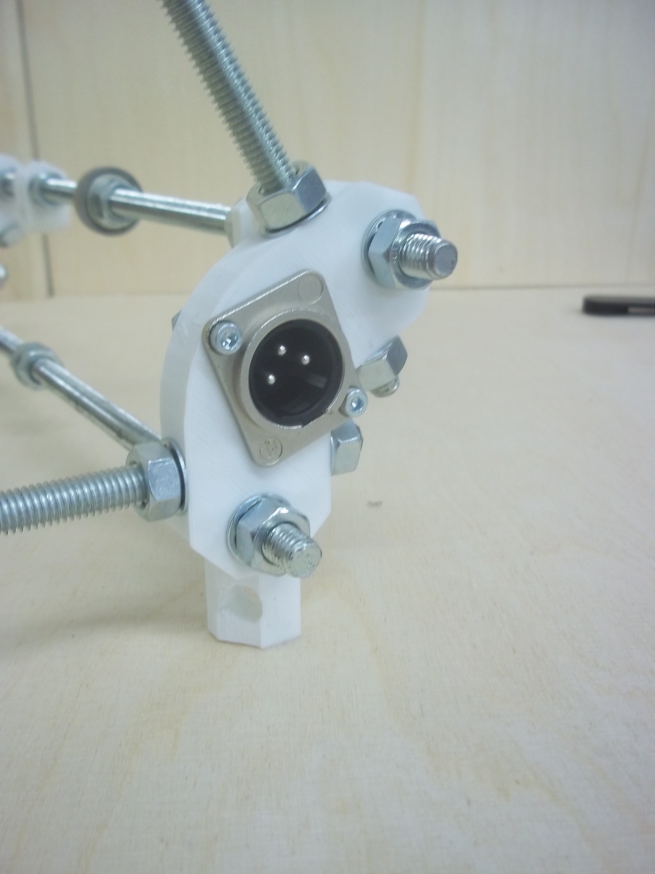

Step 5: Smooth rods
Item | Quantity
400mm smooth rods (Y) | 2
350mm smooth rods (Z) | 2
If the ends of the rods are sharp from cutting, use a file to smooth off the ends to give a small conical chamfer (0.5 .. 1 mm). Without it, there is a risk of unseating the balls inside linear bearings while inserting the rods.

Adjust the U clips for the Y rods at the front and back of the frame so that the gaps between their outer nuts and the nuts on the frame vertices are about 20mm. Slide the Y rods through. Don't tighten them:
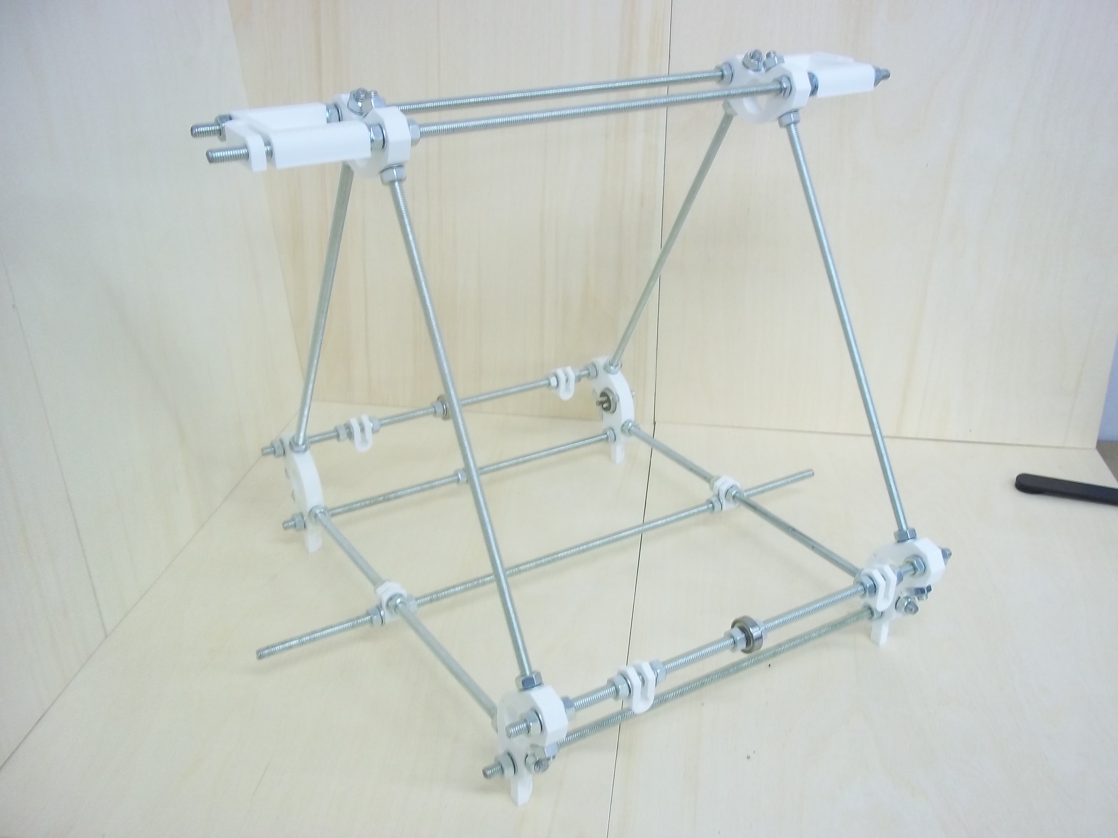
Next place the frame on a flat surface. Wooden furniture, by and large, is not flat. But thick kitchen worktops are very flat.
Chances are that the frame will rock slightly about one or the other diagonal.
Tighten the diagonal bar in such a way as to stop the rock. If the frame rocks about the bar's diagonal, the gap between its nuts needs to be bigger. If the frame rocks about the opposite diagonal, the gap between the diagonal nuts needs to be smaller.
Adjust the U clamps on the left-hand Y rod so that their nuts are 22mm from the nuts on the left frame triangle, and then adjust the right-hand Y rod U clamps so there is 175mm between the rods. Leave the clamps lose.

Aligning the Z Rods
You can now slide the two Z smooth rods into place. Do not over-tighten the clamping nuts on the Z motor mounts. The rods need to be held firm, that is all.
Use a set-square to get the angle of the Z smooth rods correct.

You can now tighten the M8 nuts along the bottom cross bar.

Frame finished
You will now have an assembled RepRapPro Mendel frame (though the smooth Y rods and the bearings will still be lose):

Next stage
assemble the Y axis.

